**AMITY SCHOOL OF ENGINEERING AND TECHNOLOGY**

**AMITY UNIVERSITY**



**BACHELOR OF TECHNOLOGY**

**IN**

**COMPUTER SCIENCE AND ENGINEERING**

**INTRODUCTION TO ARTIFICIAL INTELLIGENCE AND MACHINE LEARNING LAB FILE**

**Submitted by:** **Submitted to:**

Aman Satyam Dr. Aakanshi Gupta

Enrollment Number: A2305219642 Associate Professor

B.tech CSE CSE, DEPT

**INDEX**

|  |  |  |  |  |
| --- | --- | --- | --- | --- |
| **S.NO** | **EXPERIMENT** | **DATE** | **PG.NO** | **REMARKS** |
| **1.** | Use Python to predict employee attribution in a firm and help them plan their man power(take dataset from Kaggle) | 21/07/2022 | 3-7 |  |
| **2.** | Write a program in Python for Linear Regression | 04/08/2022 | 8-9 |  |
| **3.** | Create customer clusters using different market strategies on a data set | 11/08/2022 | 10-15 |  |
| **4.** | Write a program to implement K-means Clustering | 25/08/2022 | 16-17 |  |
| **5.** | Make a movie recommendation system | 01/09/2022 | 18-21 |  |
| **6.** | Write a program to implement Logistic regression | 15/09/2022 | 22-23 |  |
| **7.** | Develop a prediction mechanism to predict which employee can go on a leave in a company in near future | 22/09/2022 | 24-28 |  |
| **8.** | Write a program to implement a movie recommendation system | 06/10/2022 | 29-31 |  |
| **9.** | Recognizing alphabet using SVM | 20/10/2022 | 32-38 |  |
| **10.** | Write a program to implement decision tree classification algorithm | 03/11/2022 | 39-42 |  |

# **1.Use python to predict employee attrition in a firm and help them plan their manpower. (take data set from kaggle)**

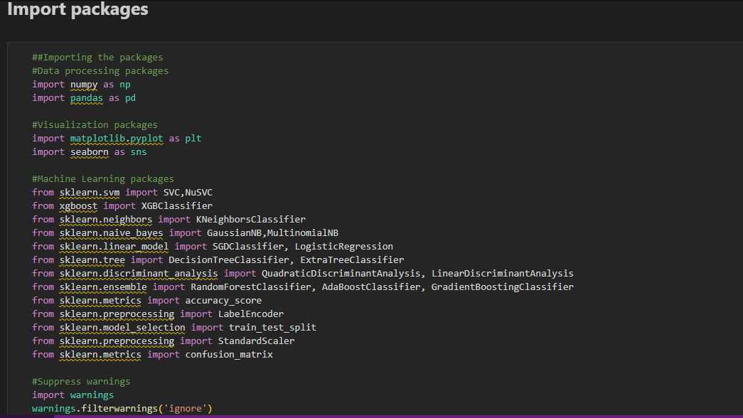 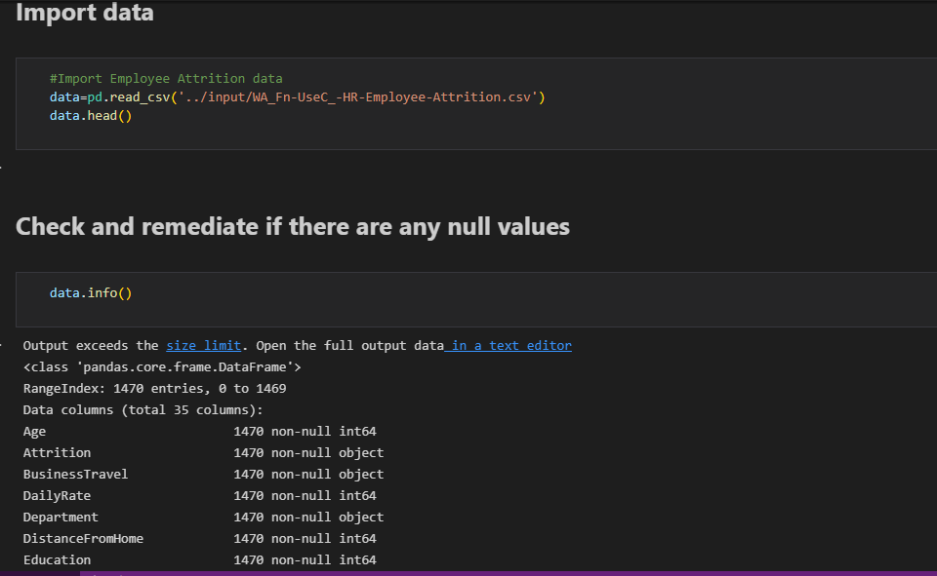 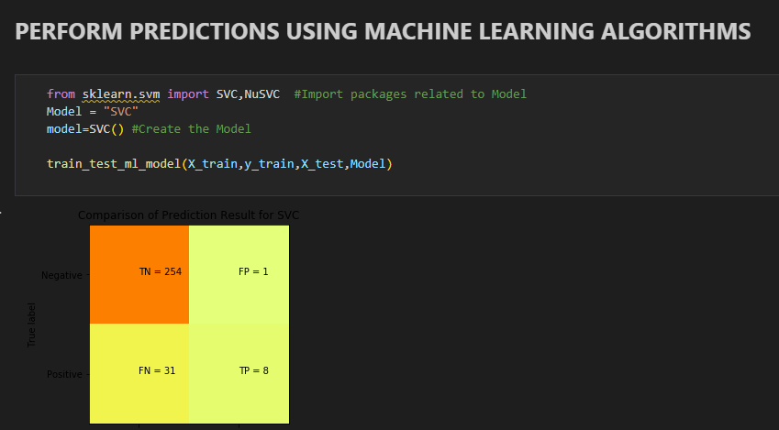 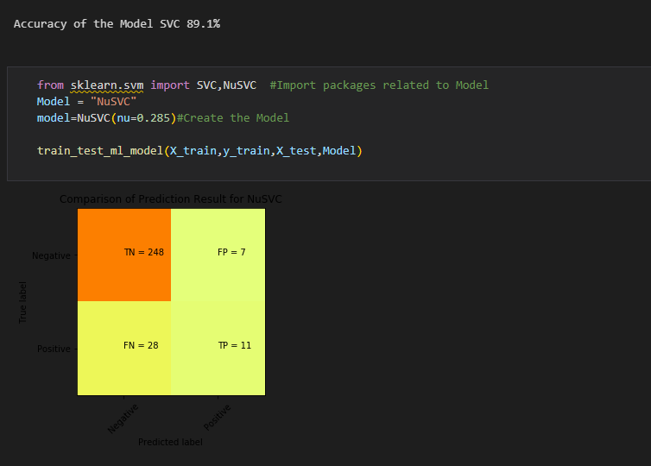 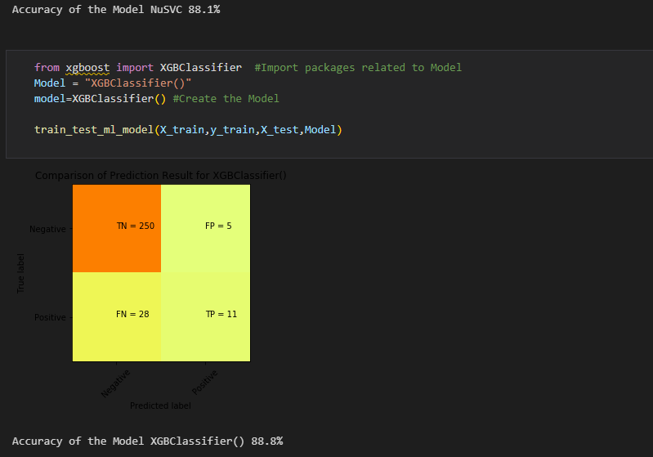 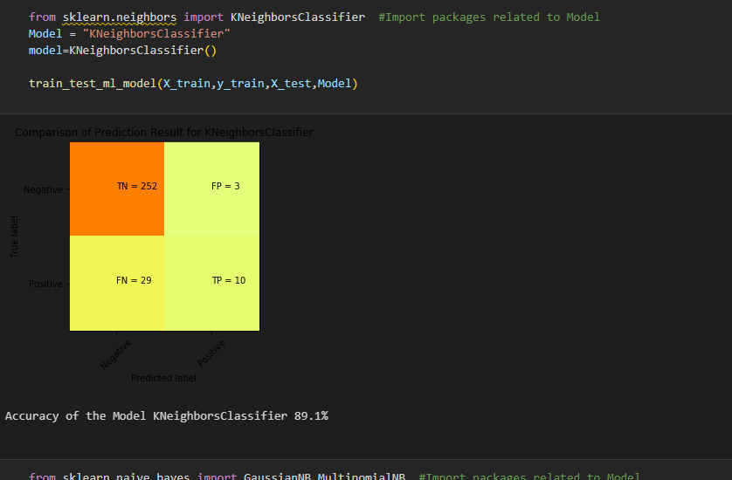 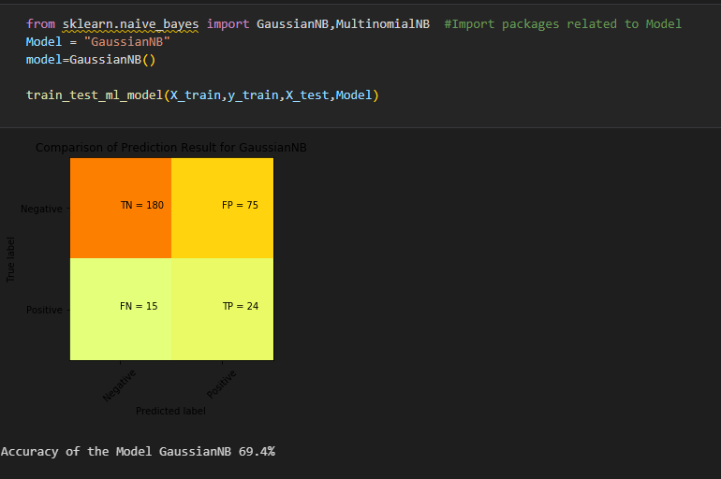 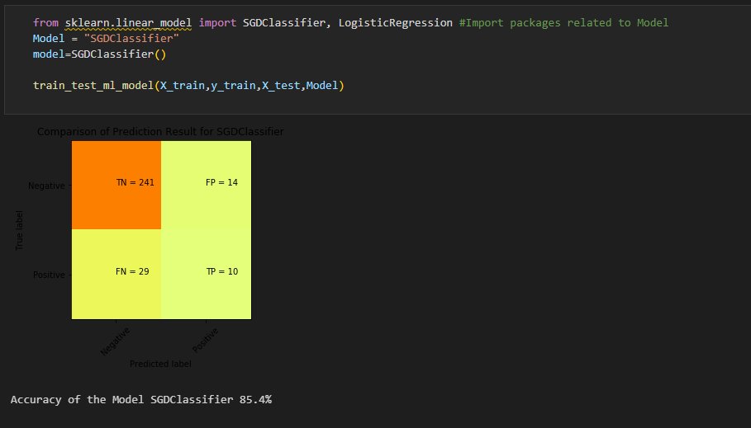 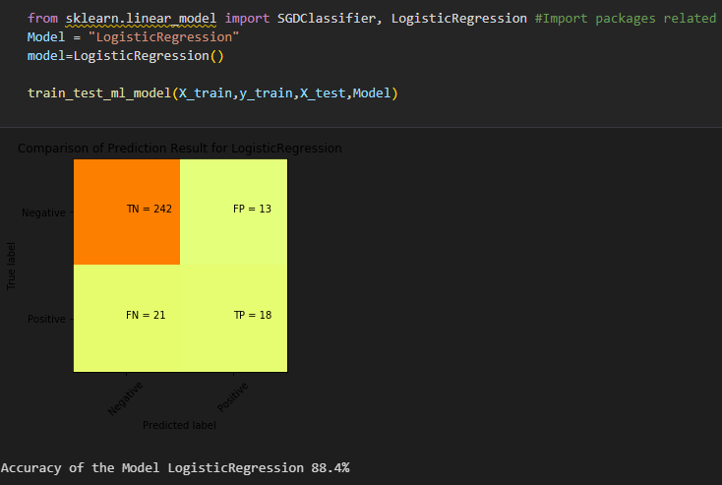

# **2.WAP in Python for the Linear regression**

import pandas as pd

import seaborn as sns

import matplotlib.pyplot as plt

import numpy as np

df=pd.read_csv(r'D:/Saksham 5th sem/Data Science/Latest Covid-19 India Status.csv')

print(df.head())

df1=df[['Total Cases']]

df2=df['Discharged']

print(df1.head())

print(df2.head())

from sklearn.model_selection import train_test_split

x_train, x_test, y_train, y_test = train_test_split(df1, df2, test_size = 0.3)

from sklearn.linear_model import LinearRegression

slr = LinearRegression()

slr.fit(x_train, y_train)

print("Intercept: ", slr.intercept_)

print("Coefficient: ", slr.coef_)

y_pred_slr= slr.predict(x_test)

print("Prediction for test set: {}".format(y_pred_slr))

slr_diff = pd.DataFrame({'Actual value': y_test, 'Predicted value': y_pred_slr})

print(slr_diff.head())

plt.scatter(x_test,y_test)

plt.plot(x_test, y_pred_slr, 'Red')

plt.show()

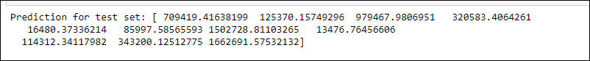

# **3. Create customer clusters using different market strategies on a data set.**

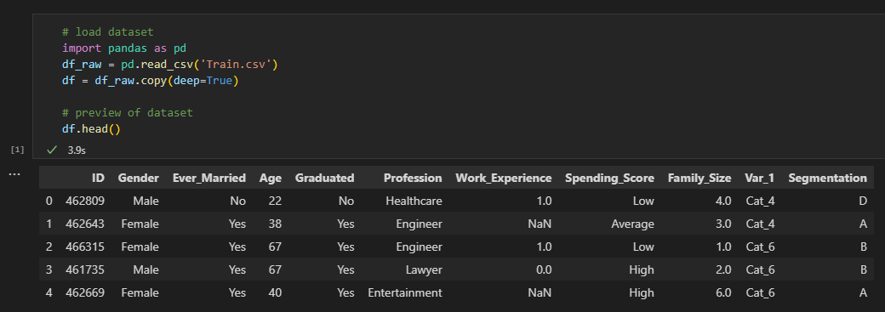 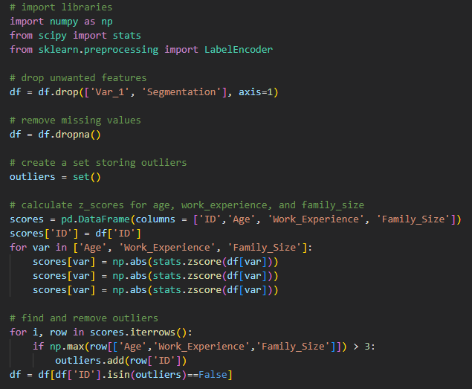 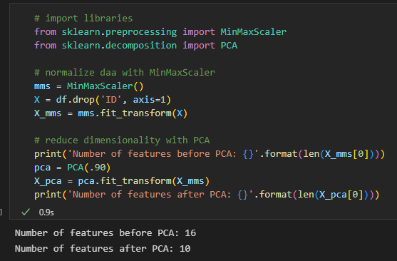 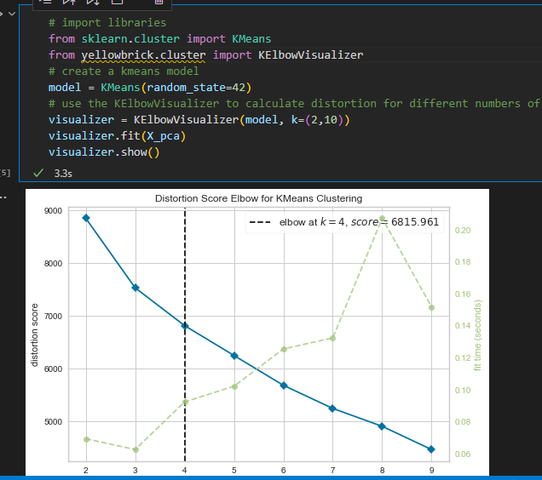 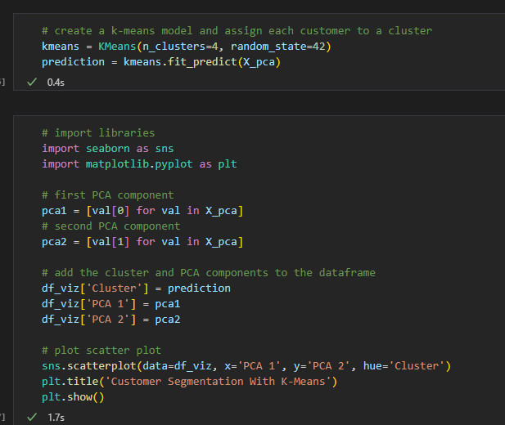 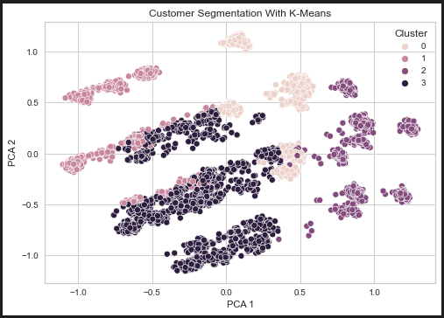 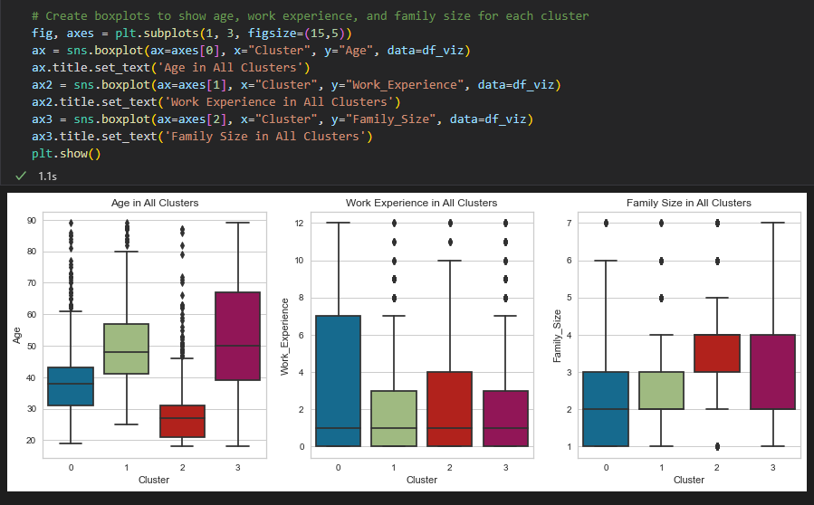 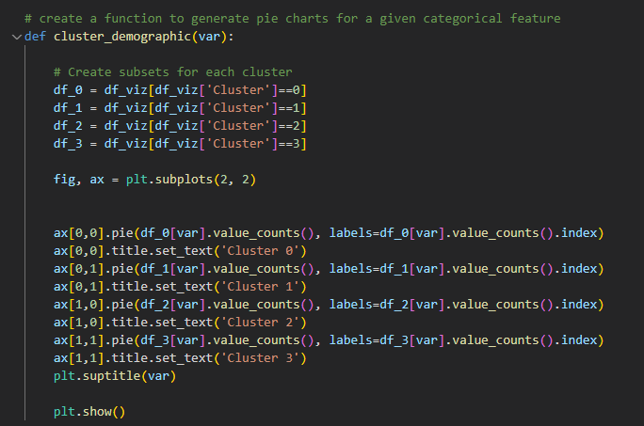 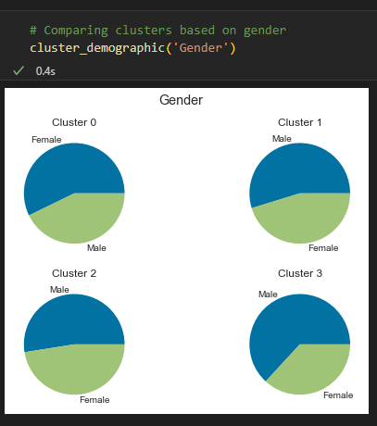 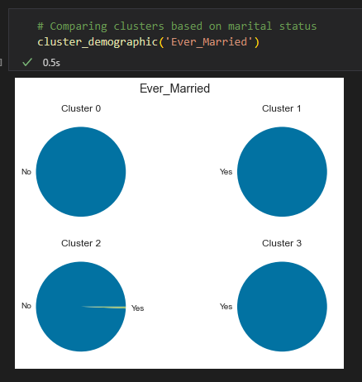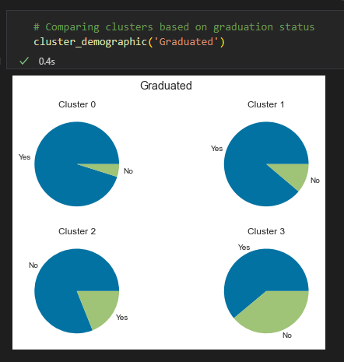 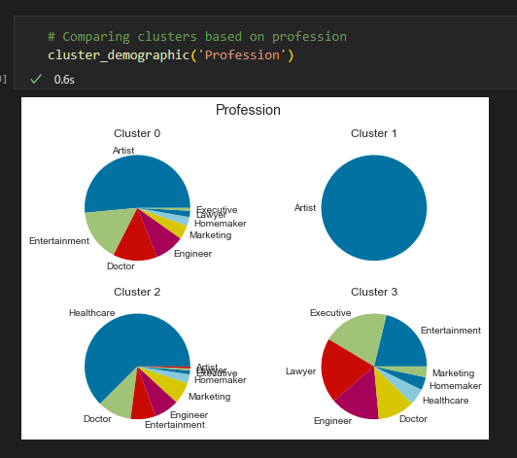 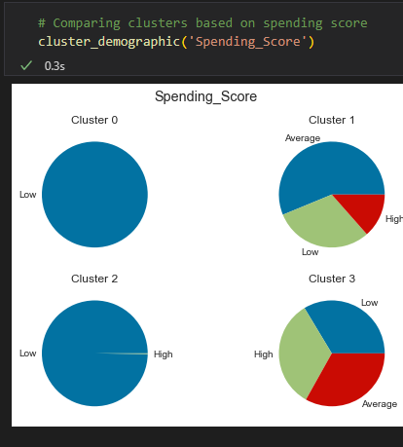

# **4.WAP to implement K-means clustering**

import pandas as pd

import numpy as np

import seaborn as sns

import matplotlib.pyplot as plt

from sklearn import datasets

iris = datasets.load_iris()

iris_df = pd.DataFrame(iris.data, columns = iris.feature_names)

iris_df.head()

from sklearn.cluster import KMeans

wcss = []

x = data.iloc[:, [0, 1, 2, 3]].values

for i in range(1, 11):

kmeans = KMeans(n_clusters = i, init = 'k-means++',

max_iter = 300, n_init = 10, random_state = 0)

kmeans.fit(x)

wcss.append(kmeans.inertia_)

plt.plot(range(1, 11), wcss)

plt.title('The elbow method')

plt.xlabel('Number of clusters')

plt.ylabel('WCSS')

plt.show()

kmeans = KMeans(n_clusters = 3, init = 'k-means++',

max_iter = 300, n_init = 10, random_state = 0)

y_kmeans = kmeans.fit_predict(x)

plt.scatter(x[y_kmeans == 0, 0], x[y_kmeans == 0, 1],

s = 100, c = 'red', label = 'Iris-setosa')

plt.scatter(x[y_kmeans == 1, 0], x[y_kmeans == 1, 1],

s = 100, c = 'blue', label = 'Iris-versicolour')

plt.scatter(x[y_kmeans == 2, 0], x[y_kmeans == 2, 1],

s = 100, c = 'green', label = 'Iris-virginica')

plt.scatter(kmeans.cluster_centers_[:, 0], kmeans.cluster_centers_[:,1],

s = 100, c = 'yellow', label = 'Centroids')

plt.legend()

# **5. Make a movie recommendation system.**

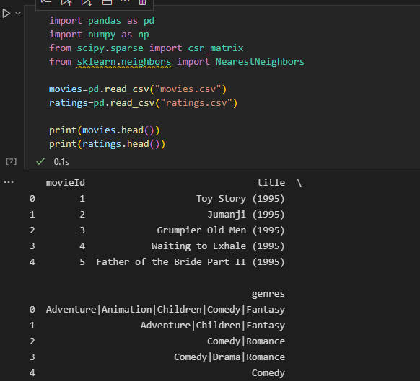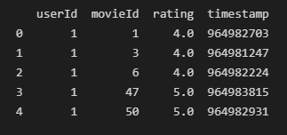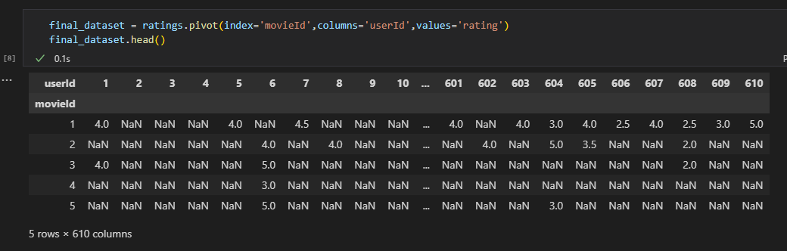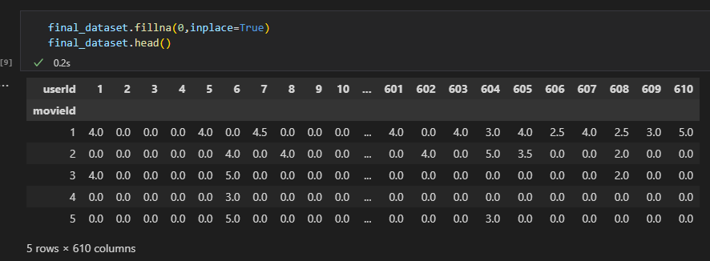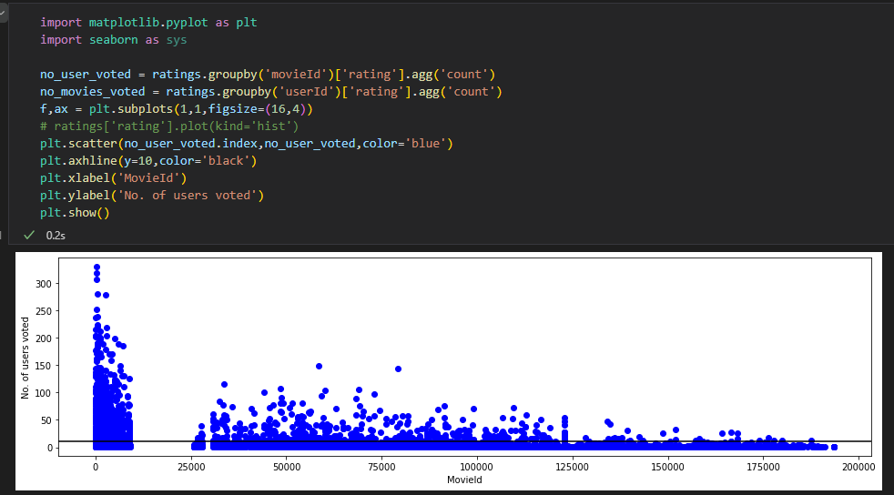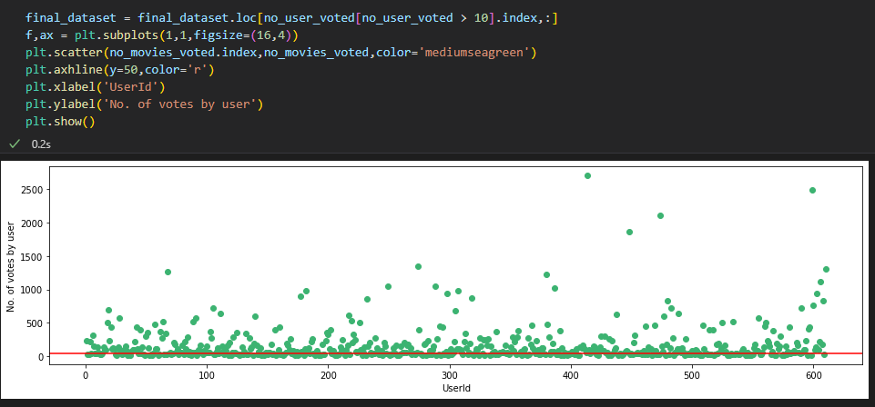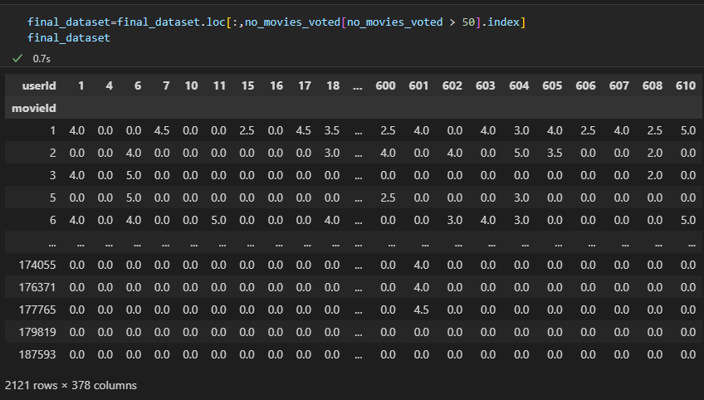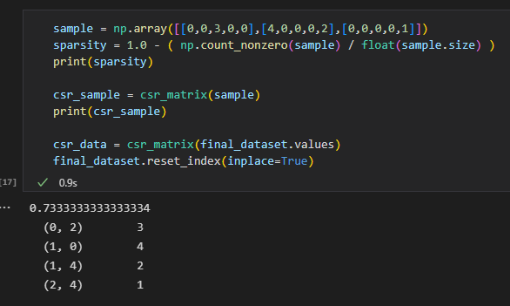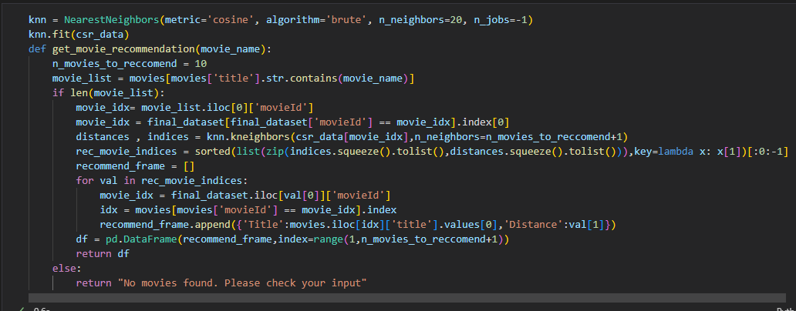

# **6. WAP to implement logistic regression**

import pandas as pd

col_names = ['pregnant', 'glucose', 'bp', 'skin', 'insulin', 'bmi', 'pedigree', 'age', 'label']

pima = pd.read_csv("pima-indians-diabetes.csv", header=None, names=col_names)

feature_cols = ['pregnant', 'insulin', 'bmi', 'age','glucose','bp','pedigree']

X = pima[feature_cols]

y = pima.label

from sklearn.model_selection import train_test_split

X_train, X_test, y_train, y_test = train_test_split(X, y, test_size=0.25, random_state=16)

from sklearn.linear_model import LogisticRegression

logreg = LogisticRegression(random_state=16)

logreg.fit(X_train, y_train)

y_pred = logreg.predict(X_test)

from sklearn import metrics

cnf_matrix = metrics.confusion_matrix(y_test, y_pred)

cnf_matrix

import numpy as np

import matplotlib.pyplot as plt

import seaborn as sns

class_names=[0,1]

fig, ax = plt.subplots()

tick_marks = np.arange(len(class_names))

plt.xticks(tick_marks, class_names)

plt.yticks(tick_marks, class_names)

sns.heatmap(pd.DataFrame(cnf_matrix), annot=True, cmap="YlGnBu" ,fmt='g')

ax.xaxis.set_label_position("top")

plt.tight_layout()

plt.title('Confusion matrix', y=1.1)

plt.ylabel('Actual label')

plt.xlabel('Predicted label')

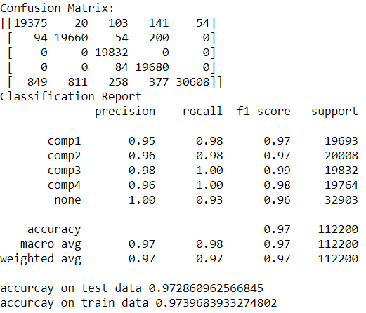

# **7. Develop a prediction mechanism to predict which employee can go on leave in a company in near future**

import matplotlib.pyplot as plt

import pandas as pd

dataset = pd.read_excel('Job.xlsx')

data=dataset.iloc[:,6].values

df=pd.DataFrame()

i=0

while i<len(data):

if(data[i]==1):

a=[dataset.iloc[i,:].values]

df1=pd.DataFrame(a)

df=df.append(df1)

i=i+1

else:

i=i+1

df=df.reset_index()

df=df.drop('index',1)

# Preprocessing

X=dataset.iloc[:,[4,7,9]].values

X=pd.DataFrame(X)

y=dataset.iloc[:,[6]].values

from sklearn.preprocessing import OneHotEncoder,LabelEncoder

label=LabelEncoder()

X[2]=label.fit_transform(X[2])

one=OneHotEncoder(categorical_features=[2])

X=one.fit_transform(X).toarray()

from sklearn.cross_validation import train_test_split

X_train,X_test,y_train,y_test=train_test_split(X,y,test_size=0.2,random_state=0)

# Plotting Of Graph

plt.hist(df[0])

plt.hist(df[1])

plt.hist(df[2])

plt.hist(df[3])

plt.hist(df[4])

plt.hist(df[5])

# Reason For Leaving The Company

Reason1=pd.DataFrame()

i=0

WithorNotWorkAccident=0

while i<len(data):

if(dataset.iloc[[i],0].values> 0.5 and dataset.iloc[[i],1].values > 0.5 and dataset.iloc[[i],4].values> 4):

a=[dataset.iloc[i,[7,9]].values]

df1=pd.DataFrame(a)

Reason1=Reason1.append(df1)

i=i+1

WithorNotWorkAccident=WithorNotWorkAccident+1

else:

i=i+1

Reason1=Reason1.reset_index()

Reason1=Reason1.drop('index',1)

Reason2=pd.DataFrame()

i=0

WithWorkAccident=0

while i<len(data):

if(dataset.iloc[[i],0].values> 0.5 and dataset.iloc[[i],1].values > 0.5 and dataset.iloc[[i],4].values> 4 and dataset.iloc[[i],5].values==1):

a=[dataset.iloc[i,[7,9]].values]

df1=pd.DataFrame(a)

Reason2=Reason2.append(df1)

i=i+1

WithWorkAccident=WithWorkAccident+1

else:

i=i+1

Reason2=Reason2.reset_index()

Reason2=Reason2.drop('index',1)

Reason2WithoutAcc=pd.DataFrame()

i=0

WithoutWorkAccident=0

while i<len(data):

if(dataset.iloc[[i],0].values> 0.5 and dataset.iloc[[i],1].values > 0.5 and dataset.iloc[[i],4].values> 4 and dataset.iloc[[i],5].values==0):

a=[dataset.iloc[i,[7,9]].values]

df1=pd.DataFrame(a)

Reason2WithoutAcc=Reason2WithoutAcc.append(df1)

i=i+1

WithoutWorkAccident=WithoutWorkAccident+1

else:

i=i+1

Reason2WithoutAcc=Reason2WithoutAcc.reset_index()

Reason2WithoutAcc=Reason2WithoutAcc.drop('index',1)

Reason3=pd.DataFrame()

i=0

WithHigherProjects=0

while i<len(data):

if(dataset.iloc[[i],0].values> 0.5 and dataset.iloc[[i],1].values > 0.5 and dataset.iloc[[i],4].values> 4 and dataset.iloc[[i],2].values>3):

a=[dataset.iloc[i,[7,8,9]].values]

df1=pd.DataFrame(a)

Reason3=Reason3.append(df1)

i=i+1

WithHigherProjects=WithHigherProjects+1

else:

i=i+1

Reason3=Reason3.reset_index()

Reason3=Reason3.drop('index',1)

Reason4=pd.DataFrame()

i=0

WithPromotion=0

while i<len(data):

if(dataset.iloc[[i],0].values> 0.5 and dataset.iloc[[i],1].values > 0.5 and dataset.iloc[[i],4].values> 4 and dataset.iloc[[i],2].values>3 and dataset.iloc[[i],7].values==1):

a=[dataset.iloc[i,[9]].values]

df1=pd.DataFrame(a)

Reason4=Reason4.append(df1)

i=i+1

WithPromotion=WithPromotion+1

else:

i=i+1

Reason4=Reason4.reset_index()

Reason4=Reason4.drop('index',1)

Reason5=pd.DataFrame()

i=0

WithLowerSalary=0

while i<len(data):

if(dataset.iloc[[i],0].values> 0.5 and dataset.iloc[[i],1].values > 0.5 and dataset.iloc[[i],4].values> 4 and dataset.iloc[[i],2].values>3 and dataset.iloc[[i],9].values=='low'):

a=[dataset.iloc[i,[7]].values]

df1=pd.DataFrame(a)

Reason5=Reason5.append(df1)

i=i+1

WithLowerSalary=WithLowerSalary+1

else:

i=i+1

Reason5=Reason5.reset_index()

Reason5=Reason5.drop('index',1)

Reason6=pd.DataFrame()

i=0

WithHigherTime=0

while i<len(data):

if(dataset.iloc[[i],0].values> 0.5 and dataset.iloc[[i],1].values > 0.5 and dataset.iloc[[i],4].values> 4 and dataset.iloc[[i],2].values>3 and dataset.iloc[[i],3].values>200):

a=[dataset.iloc[i,[9]].values]

df1=pd.DataFrame(a)

Reason6=Reason6.append(df1)

i=i+1

WithHigherTime=WithHigherTime+1

else:

i=i+1

Reason6=Reason6.reset_index()

Reason6=Reason6.drop('index',1)

b=[WithHigherProjects,WithLowerSalary,WithHigherTime,WithPromotion,WithWorkAccident,WithorNotWorkAccident,WithoutWorkAccident]

Visual=pd.DataFrame(b)

ax = Visual[0].plot(kind='bar', title ="V comp", figsize=(15, 10), legend=True, fontsize=12)

ax.set_xlabel("Factors Affecting Employess", fontsize=12)

ax.set_ylabel("Values", fontsize=12)

plt.show()

# Regression Models

from sklearn.linear_model import LinearRegression

regressor = LinearRegression()

regressor.fit(X_train, y_train)

y_pred_linear = regressor.predict(X_test)

from sklearn.tree import DecisionTreeClassifier

Classifier = DecisionTreeClassifier(criterion = 'entropy', random_state = 0)

Classifier.fit(X_train, y_train)

y_pred_decision = Classifier.predict(X_test)

from sklearn.metrics import confusion_matrix

cm = confusion_matrix(y_test, y_pred_decision)

from sklearn.ensemble import RandomForestClassifier

Classifier1 = RandomForestClassifier(n_estimators = 5, criterion = 'entropy', random_state = 0)

Classifier1.fit(X_train, y_train)

y_pred_RandomForest = Classifier1.predict(X_test)

from sklearn.metrics import confusion_matrix

cm1 = confusion_matrix(y_test, y_pred_RandomForest)

from sklearn.linear_model import LogisticRegression

classifier2=LogisticRegression(random_state=0)

classifier2.fit(X_train,y_train)

y_pred_LR=classifier2.predict(X_test)

from sklearn.metrics import confusion_matrix

cm2 = confusion_matrix(y_test, y_pred_LR)

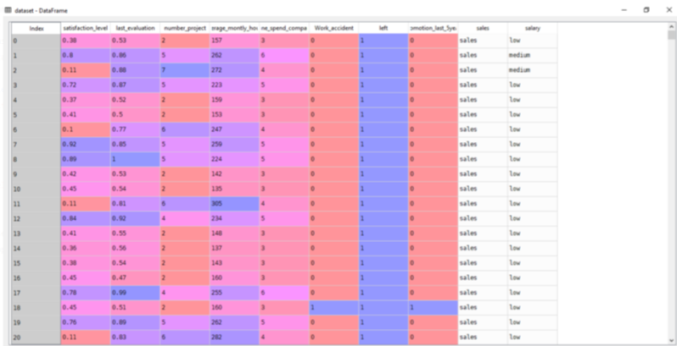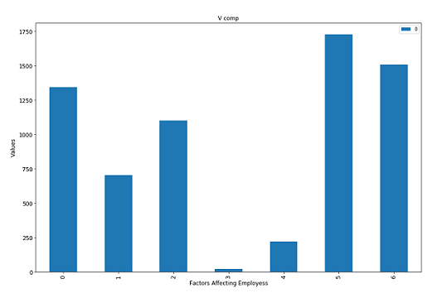

# **8.WAP to implement a movie recommendation system**

import pandas as pd

column_names = ['user_id', 'item_id', 'rating', 'timestamp']

path = ‘C://wp-content/uploads/file.tsv'

df = pd.read_csv(path, sep='\t', names=column_names)

df.head()

movie_titles = pd.read_csv('https://media.geeksforgeeks.org/wp-content/uploads/Movie_Id_Titles.csv')

movie_titles.head()

ratings = pd.DataFrame(data.groupby('title')['rating'].mean())

ratings['num of ratings'] = pd.DataFrame(data.groupby('title')['rating'].count())

ratings.head()

import matplotlib.pyplot as plt

import seaborn as sns

sns.set_style('white')

%matplotlib inline

plt.figure(figsize =(10, 4))

ratings['num of ratings'].hist(bins = 70)

# plot graph of 'ratings' column

plt.figure(figsize =(10, 4))

ratings['rating'].hist(bins = 70)

moviemat = data.pivot_table(index ='user_id',

columns ='title', values ='rating')

moviemat.head()

ratings.sort_values('num of ratings', ascending = False).head(10)

similar_to_starwars = moviemat.corrwith(starwars_user_ratings)

similar_to_liarliar = moviemat.corrwith(liarliar_user_ratings)

corr_starwars = pd.DataFrame(similar_to_starwars, columns =['Correlation'])

corr_starwars.dropna(inplace = True)

corr_starwars.head()

corr_starwars.sort_values('Correlation', ascending = False).head(10)

corr_starwars = corr_starwars.join(ratings['num of ratings'])

corr_starwars.head()

corr_starwars[corr_starwars['num of ratings']>100].sort_values('Correlation', ascending = False).head()

# **9. Recognizing alphabets using SVM.**

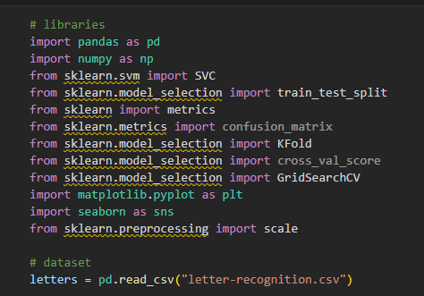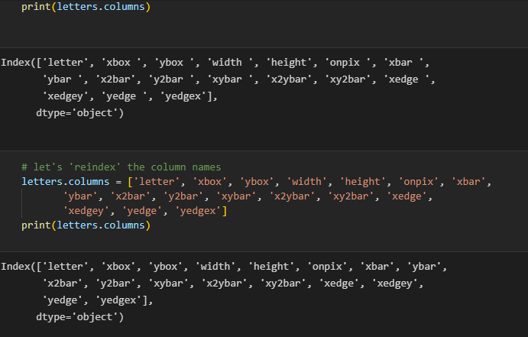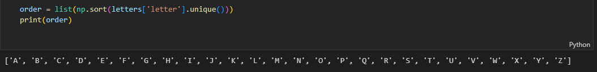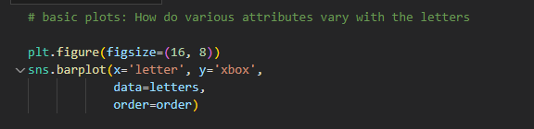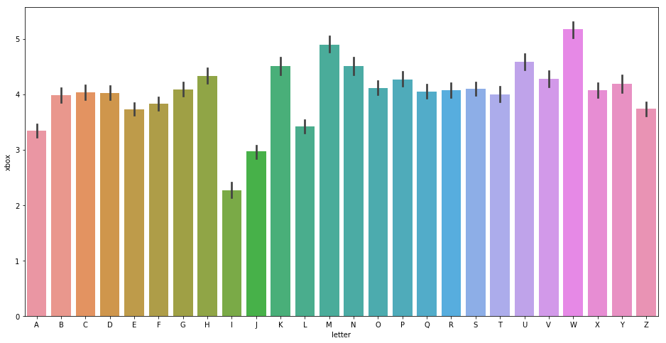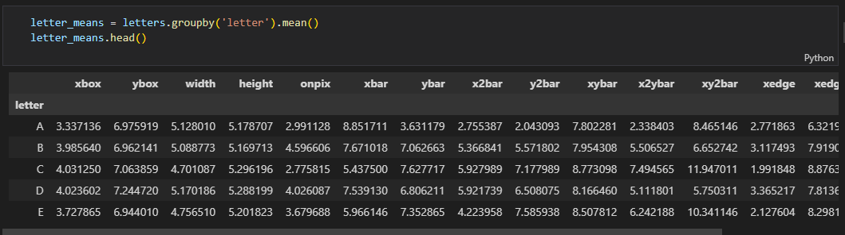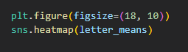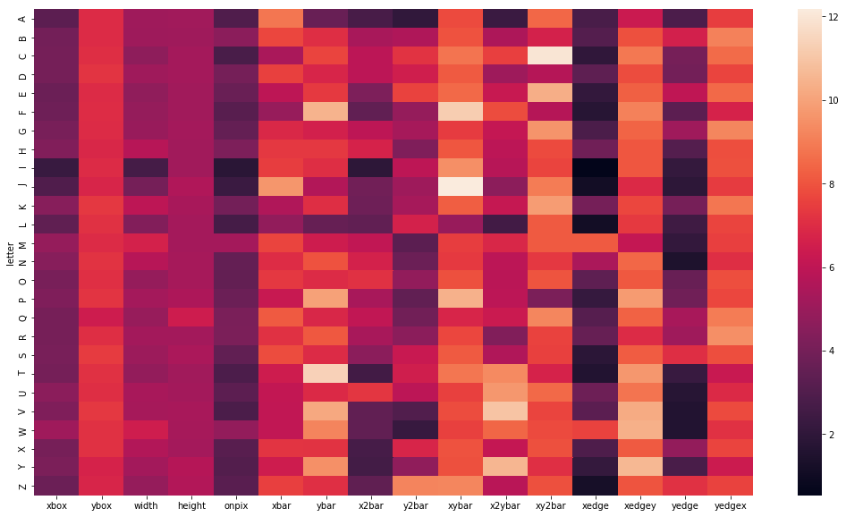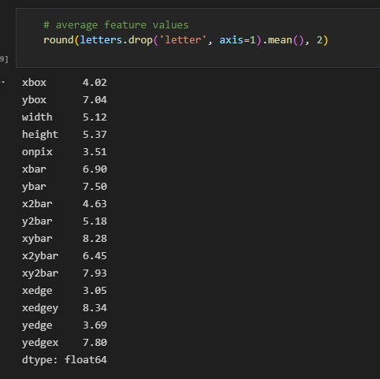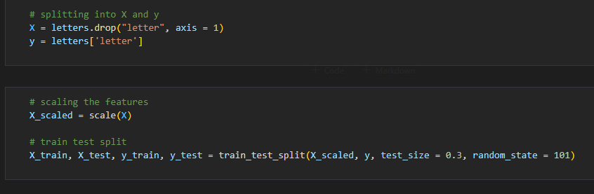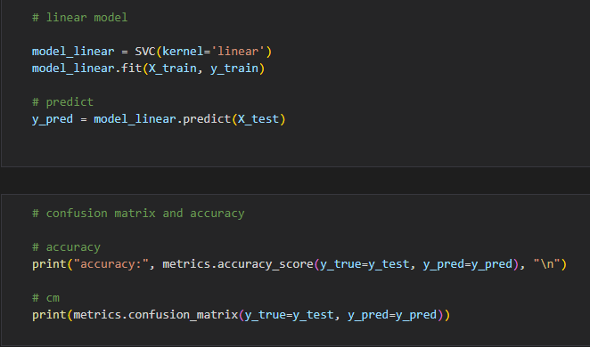 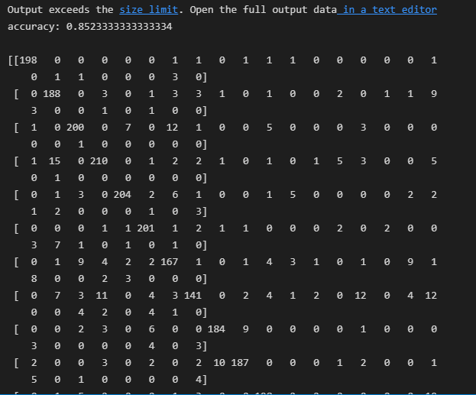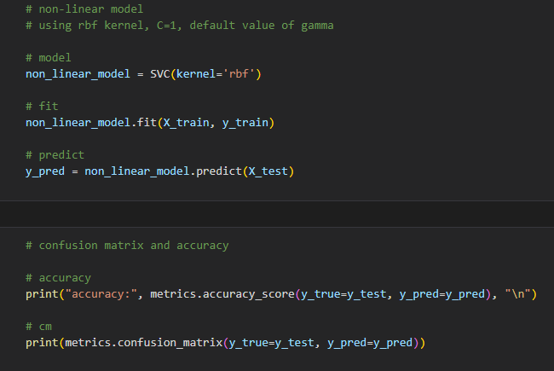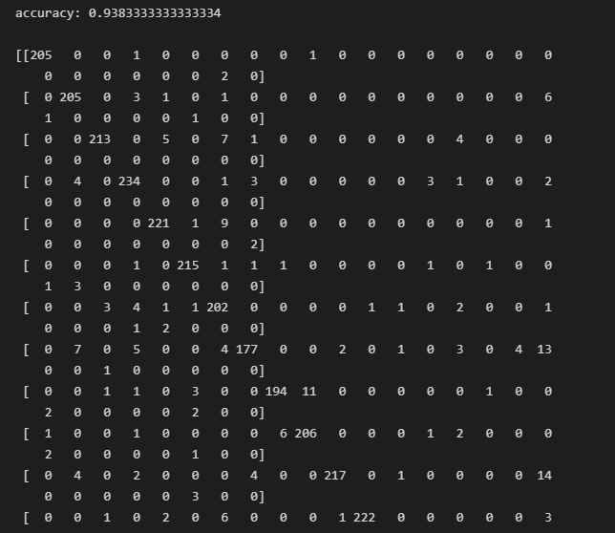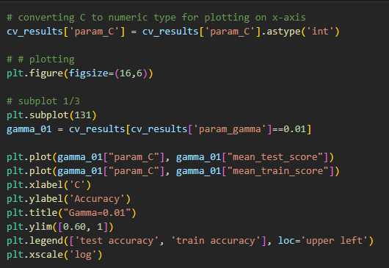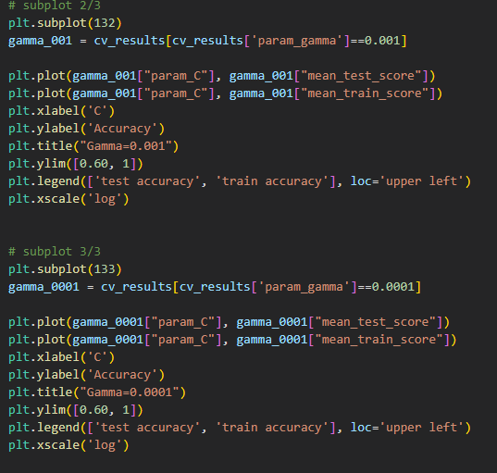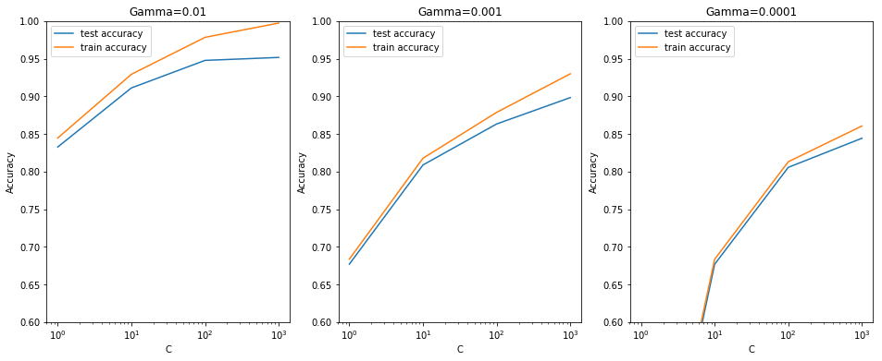

# **10.WAP to implement decision tree classification algorithm**

import numpy as np

import pandas as pd

from sklearn.metrics import confusion_matrix

from sklearn.model_selection import train_test_split

from sklearn.tree import DecisionTreeClassifier

from sklearn.metrics import accuracy_score

from sklearn.metrics import classification_report

def importdata():

balance_data = pd.read_csv(

'https://archive.ics.uci.edu/ml/machine-learning-'+

'databases/balance-scale/balance-scale.data',

sep= ',', header = None)

print ("Dataset Length: ", len(balance_data))

print ("Dataset Shape: ", balance_data.shape)

print ("Dataset: ",balance_data.head())

return balance_data

def splitdataset(balance_data):

# Separating the target variable

X = balance_data.values[:, 1:5]

Y = balance_data.values[:, 0]

X_train, X_test, y_train, y_test = train_test_split(

X, Y, test_size = 0.3, random_state = 100)

return X, Y, X_train, X_test, y_train, y_test

def train_using_gini(X_train, X_test, y_train):

clf_gini = DecisionTreeClassifier(criterion = "gini",

random_state = 100,max_depth=3, min_samples_leaf=5)

# Performing training

clf_gini.fit(X_train, y_train)

return clf_gini

def tarin_using_entropy(X_train, X_test, y_train):

clf_entropy = DecisionTreeClassifier(

criterion = "entropy", random_state = 100,

max_depth = 3, min_samples_leaf = 5)

# Performing training

clf_entropy.fit(X_train, y_train)

return clf_entropy

def prediction(X_test, clf_object):

# Predicton on test with giniIndex

y_pred = clf_object.predict(X_test)

print("Predicted values:")

print(y_pred)

return y_pred

def cal_accuracy(y_test, y_pred):

print("Confusion Matrix: ",

confusion_matrix(y_test, y_pred))

print ("Accuracy : ",

accuracy_score(y_test,y_pred)*100)

print("Report : ",

classification_report(y_test, y_pred))

def main():

data = importdata()

X, Y, X_train, X_test, y_train, y_test = splitdataset(data)

clf_gini = train_using_gini(X_train, X_test, y_train)

clf_entropy = tarin_using_entropy(X_train, X_test, y_train)

print("Results Using Gini Index:")

y_pred_gini = prediction(X_test, clf_gini)

cal_accuracy(y_test, y_pred_gini)

print("Results Using Entropy:")

y_pred_entropy = prediction(X_test, clf_entropy)

cal_accuracy(y_test, y_pred_entropy)

if __name__=="__main__":

main()

